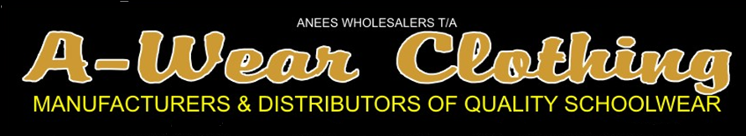
 | BOYS | SCHOOL | HOSE
COLOUR | 9 X 12 - S | 12 X 3 - M | 4 X 7 - L
BLACK/WHITE
BLACK/GOLD
BLACK/RED
BLACK/EMERALD
BLACK/SKY
BLACK/ORANGE
NAVY/EMERALD
NAVY/GOLD
NAVY/RED
NAVY/SKY
NAVY/WHITE
MAROON/GOLD
MAROON/SKY
MAROON/GREY
MAROON/WHITE
BOT.GREEN/GOLD
BOT.GREEN/WHITE
BOT.GREEN/RED
ROYAL/RED
ROYAL/WHITE
ROYAL/GOLD
GREY/GOLD ACRY
GREY/MAROON ACRY
GREY/SKY ACRY
GREY/WHITE ACRY
GREY/RED ACRY
BROWN/GOLD
BROWN/BEIGE
SKY/WHITE
RED/WHITE
RED/BLACK
PLAIN BLACK
PLAIN NAVY
PLAIN MAROON
PLAIN GREEN
PLAIN GREY ACRYLIC
PLAIN WHITE ACRY

