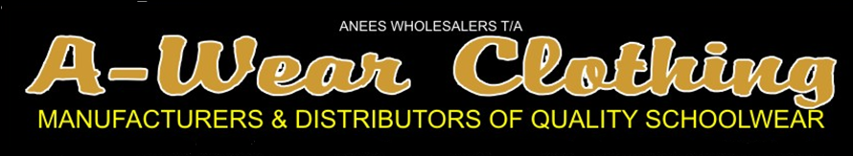

SERGE SCHOOL SHORTS
REF: | COLOUR | 22 | 24 | 26 | 28 | 30 | 32 | 34 | 36 | 38 | 40 | 42
Y712 | BLACK
Y710 | NAVY
Y709 | KHAKI
Y711 | GREY
Y708 | MAROON
Y707 | BOT.GRN
Y706 | BROWN
Y715 | ROYAL

